LeetCode Program 1523
Link :- https://leetcode.com/problems/count-odd-numbers-in-an-interval-range/

Successful Submission 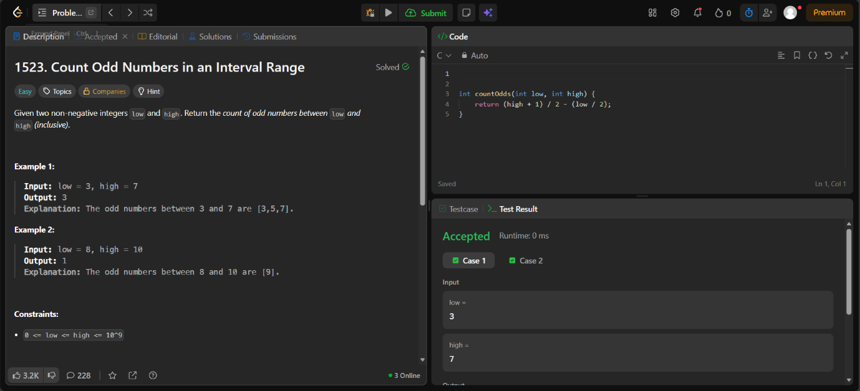
Source Code


